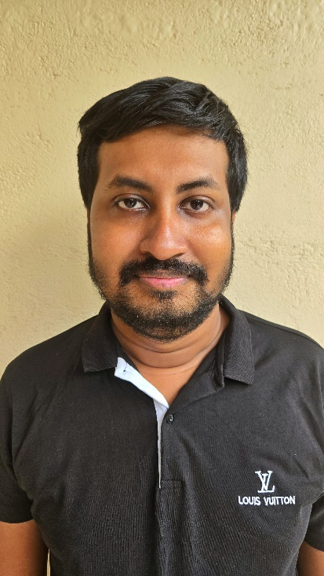

**SUMMARY**

As a Software Engineering graduate from Plymouth University, UK, I am a skilled full-stack developer and a collaborative team player with strong project management abilities. I have a keen interest in web and mobile development technologies and expertise in tools and frameworks such as JavaScript, AngularJS, Node.js, React, JSP, Android, Flutter, and Python. Additionally, I am proficient in data storage technologies, including SQL, NoSQL (Firebase/Firestore), and MongoDB. I am working as a freelance developer, leveraging my skills to deliver innovative and tailored solutions to clients.

**PERSONAL INFORMATION**

FULL NAME : Dombagaha

Pathirannehalage

Ishan Gayantha

NAME WITH INITIALS: D. P. I. Gayantha

Date of Birth : 04-04-1995

Nationality : Sinhalese (Sri Lankan)

Religion : Buddhist

**CONTACT INFORMATION**

EMAIL : ishangayantha998@gmail.com

PHONE : 0725237603

LINKEDIN: <https://www.linkedin.com/in/ishan-gayantha-9b2352166/>

ADDRESS : No. 803/39,

Koralaima,

Gonapola Junction,

Horana,

Sri Lanka.

**EDUCATIONAL INFORMATION**

Passed G. C. E. O/L Examination with 8 ‘A’ Grades. Passed in year 2011.

Completed G. C. E. A/L Examination in year 2015 with Foundational program for Mathematics. (Index No: 4630637)

**ADDITIONAL QUALIFICATION**

A qualified diploma holder of **Diploma of higher education (DipHE / HND)**

A **CISCO certified Network Security certificate holder**.

A **WordPress certified web developer, Internet Marketing expert and experienced SEO analyzer**.

A qualified **Intermediate Level English certificate holder**.

**AREAS OF EXPERTISE**

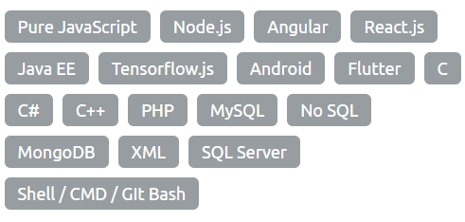

**SKILLS**

Project Management Decision Making

Creative Development Complex Problem solving

**D.P.I. Gayantha**

**CURRICULUM VITAE**

**MR. SANATH NANDASIRI**

**(Co-Founder of CeylonLabs)**

Tel: +94 (76) 322 5513

More: Get Information referring name

[sanathe06@gmail.com](mailto:ranaweera.r@nsbm.lk)

**EXPERIENCE**

As a developer,

I have developed both backend and frontend (full-stack development) of many websites using HTML, JavaScript and PHP.

I did my final project on natural disaster management solution which leads to develop collaborative system design with machine learning applications. Therefor I used JavaScript, Android and TensorFlow. ( <https://github.com/hackishmax321/weather_pannel>)

Projects undertake at **CeylonLabs (03-2021 to 09-2021)**:

**Government Project on Divisional Secretariat Offices Development Management**:

Contributed to the design and development of a comprehensive system to manage and track development works in Divisional Secretariat offices.

GitHub Repository: (<https://github.com/CeylonLab/podu-jana-palama-web.git> )

**Trix - Roadway Assistant:**

Played a key role in the development of "Trix," a roadway assistant application designed to enhance road navigation and user safety.

**Point of Sale (POS) Systems:**

Collaborated on the development of multiple POS systems, ensuring efficient and user-friendly solutions for retail and service industries.

Currently works as a freelancer developer delivering tailored software and web solutions and collaborating with clients to meet their specific project requirements.

As an active developer of several group assignments, I participated developing;

Student Management System using JSP

(<https://github.com/hackishmax321/student_management_system-jsp->)

Garbage Disposal Service using JavaScript and PHP

(<https://github.com/hackishmax321/garbage_disposal_service>)

**REFERENCES**

**MRS. MANOJA WEERARATHNA**

**(Final Project Supervisor/ Lecturer of NSBM)**

Tel: +94 (11) 544 6032 / +94 (11) 544 6000

More: Get Information by referencing final project on Disaster Management System with mobile application.

[manoja@nsbm.lk](mailto:manoja@nsbm.lk)